- The UK's housing market is gradually recovering and recent data suggest measures of mortgage stress are starting to show signs of improvement. But the outlook for mortgagors remains very challenging, so we expect arrears to remain above the pre-pandemic norm for several years.
- More stringent lending rules, low unemployment, and the prevalence of fixed-rate mortgages have meant that the recent increase in arrears has been much smaller than in previous cycles. However, some borrowers still face a large rise in debt interest costs over the next couple of years as cheap fixes expire. Older mortgage accounts, where credit quality is typically poorer, may be particularly vulnerable to the impact of resetting to higher interest rates.
- Despite higher arrears, repossessions have not yet increased substantially. We expect the number of foreclosures will continue to rise as a small proportion of older mortgages fall further behind on repayments. But lender forbearance should keep repossessions low by historical standards.
- Our scenario analysis suggests that tighter financial conditions are the key risk for arrears. If interest rates stay higher for longer, arrears could reach levels not seen since 2014.
Most housing market indicators suggest we have passed the bottom of the cycle. The combination of interest rates on new mortgages falling back from their mid-2023 peak and strong nominal earnings growth has reduced the scale of the UK's mortgage affordability problem. Mortgage activity and house prices have strengthened since the late summer, and we think a gradual recovery in the housing market is underway.
Despite this, our modelling (see Appendix) suggests that measures of mortgage stress are likely to remain elevated for several years (Chart 1). The lagged impact of past interest rate rises means many households still face a large uplift in monthly mortgage payments over the next couple of years. And with a significant proportion of existing mortgage arrears cases reflecting much older mortgage accounts, which are particularly vulnerable to higher repayments, we don't expect arrears to cure quickly.
Chart 1: Mortgage arrears have peaked at a low level, but are unlikely to fall quickly
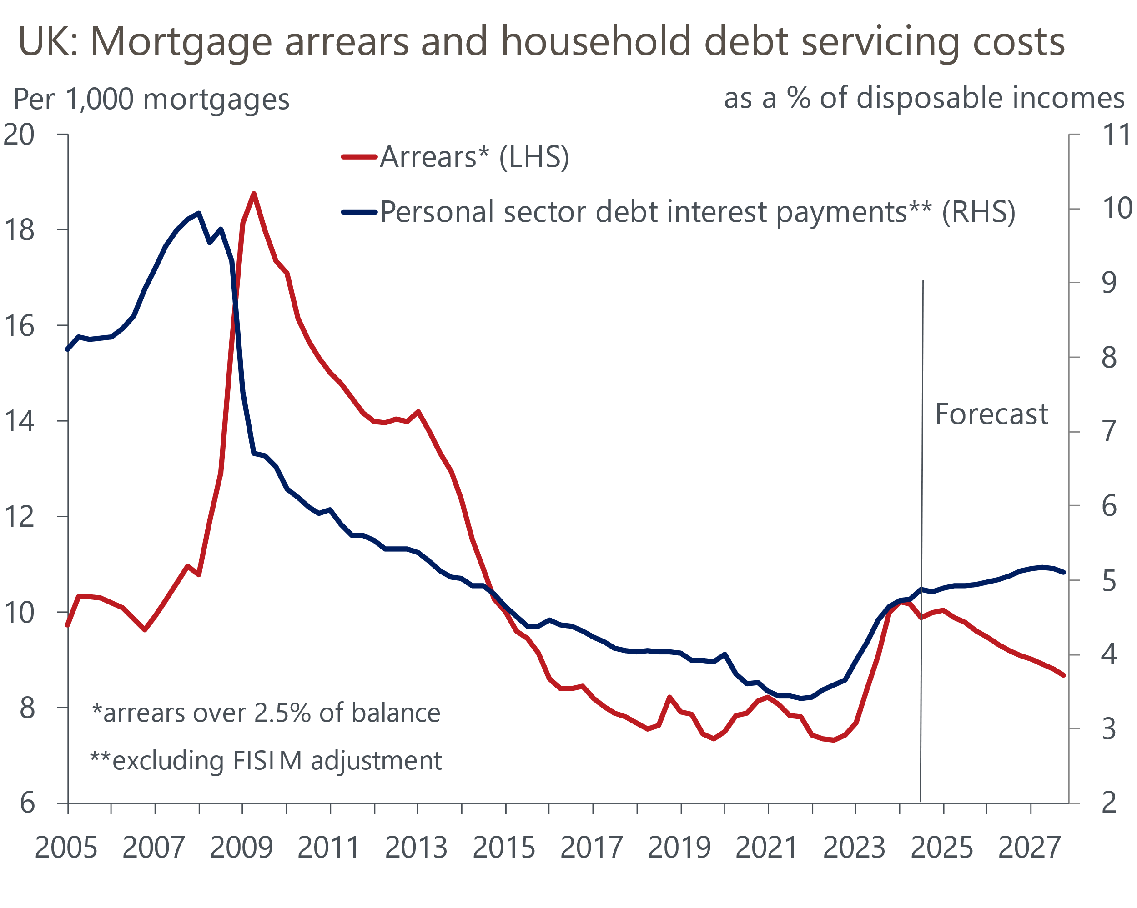
Source: Oxford Economics, Haver Analytics, UK Finance

Higher debt servicing costs drove the recent increase in mortgage arrears
In contrast to previous cycles, higher debt servicing costs, rather than a sharp rise in unemployment, was the driving force behind the increase in mortgage arrears since the start of 2023. As the Bank of England's Monetary Policy Committee raised Bank Rate to combat inflation, this first pushed up the interest rate on variable-rate mortgage deals, which accounted for the bulk of the early jump in arrears and the majority of the increase in more severe arrears cases. The impact of tighter monetary policy has been a slower burn for the 81% of mortgages that have a fixed-rate deal structure. Still, the scale of the increase in mortgage rates means overall personal sector debt interest payments (excluding FISIM) have risen sharply, jumping to 4.7% of aggregate household income in Q3 2024 from 3.5% in 2021, which has put household finances under strain.
Though arrears are well above the levels seen prior to the start of the BoE's hiking cycle, the increase has been relatively modest compared to previous cycles, such as the Global Financial Crisis (Chart 1). This likely reflects three key structural factors.
First, the BoE's Financial Policy Committee introduced more stringent mortgage lending rules in 2014 to improve credit quality. These included stress testing new borrowers against high interest rates and limiting the flow of lending to new borrowers with high income multiples. This means that mortgages taken out over the past decade are typically much less vulnerable to periods of higher interest rates than previous cohorts.
Second, unemployment has remained very low by historical standards, thereby limiting the upward pressure on arrears since job loss is usually the most likely cause of a borrower falling into arrears.
Third, the sharp rise in the utilisation of fixed-rate mortgages since the GFC means that households have moved onto more expensive deals at a much slower pace than a scenario in which variable-rate contracts were still the most popular mortgage structure. Not only did this shield most mortgagors from the higher interest rates on variable-rate mortgages, it also provided many households with an opportunity to build a buffer of savings in anticipation of higher future mortgage payments.

We think arrears cases have probably peaked
Though reported mortgage arrears take time to accrue, recent data suggest we are now entering into a new phase of the cycle. Following a sharp rise which started in early 2023, UK Finance's measure of arrears cases fell fractionally in Q2 and Q3 2024 due to lower early arrears (Chart 2). However, this shift also saw a marked increase in the severity of existing arrears.
Chart 2: Total arrears have started to fall, but severe arrears cases continue to rise
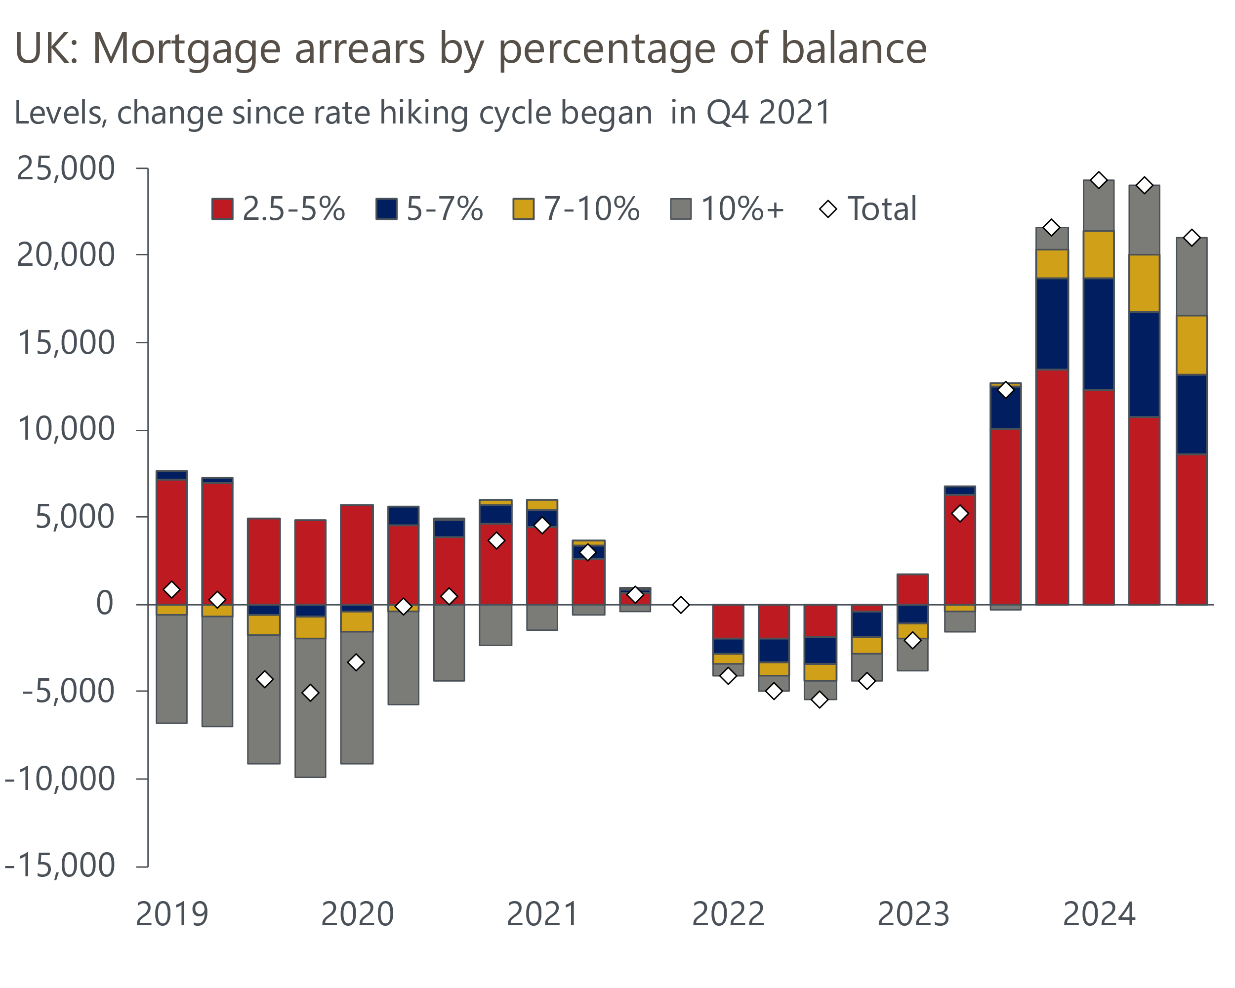
Source: UK Finance

But measures of mortgage stress are likely to remain elevated for a prolonged period
We expect this trend to continue, but the fall in arrears will be slow. We expect the labour market to remain relatively resilient, with unemployment staying close to current levels and nominal earnings continuing to grow at a decent pace.
We expect the MPC will continue to gradually loosen policy, with Bank Rate set to fall to 3.75% by the end of 2025. But only around one-eighth of outstanding mortgages are on variables rates.
The BoE's latest Financial Stability Report outlined that roughly 50% of all mortgage accounts are expected to refinance onto higher interest rates between December 2024 and Q4 2027. Data from the Financial Conduct Authority suggests that about 1mn borrowers will need to refinance fixed-rate deals that expire this year alone. Borrowers with two-year fixes expiring will likely reset at a lower level than their expiring deal. But the 37% of mortgage accounts that still haven't had to refinance since interest rates started to rise in late 2021 all face a large increase in debt servicing costs. We estimate that mortgagors coming to the end of five-year fixes in 2025 will face an uplift in their interest rate of around 250bps (Chart 3).
Chart 3: Many mortgagors face refinancing at much higher interest rates in 2025 and 2026
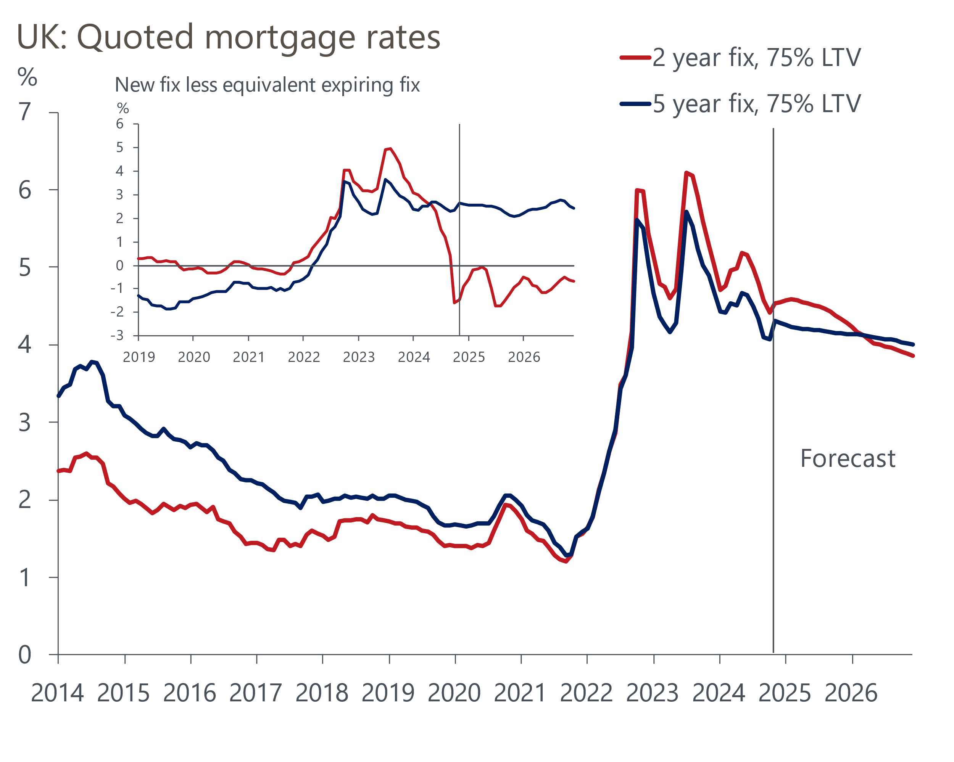
Sources: Haver Analytics, Oxford Economics
The scale of the increase in monthly payments for these borrowers means many remain vulnerable to falling into arrears over the coming years. Though stringent lending rules introduced in 2014 should mean that most households who have taken out a mortgage over the past decade are unlikely to fall into arrears, the majority of current arrears cases relate to mortgages taken out before these rules were put in place. Within this cohort of mortgagors, the level and severity of reported arrears is still rising sharply even as overall arrears have levelled off. As a result, the greater sensitivity to higher interest rates and the large arrears balances for these older mortgage accounts suggest that the number of arrears cases will fall back only gradually over the coming years.

Repossessions are set to grind upwards
Despite the sharp rise in arrears since late 2022, there has been little upward pressure on mortgage repossessions. Repossessions dropped to an artificially low level during the pandemic as the government implemented a year-long moratorium on foreclosures. Nevertheless, the uptick in repossessions since the moratorium ended in March 2021 has been muted – the level in Q3 2024 was still almost 20% below the average for the five years before the pandemic. The main reason for this is a gradual trend towards lenders offering borrowers greater forbearance options before a house is repossessed.
The long time lags involved for arrears to build to a sufficient level of severity and for the foreclosure process to be undertaken means it's unlikely that repossessions have peaked in this cycle yet. UK Finance reports that the vast majority of cases currently going through the repossession process relate to older mortgages that have typically been in arrears for several years. We think repossessions are likely to slowly grind upwards as the interest rate on outstanding mortgages remains elevated, resulting in the most vulnerable older mortgages falling further behind on repayments (Chart 4).
Chart 4: Repossessions remain low, but older mortgages will be vulnerable to foreclosure
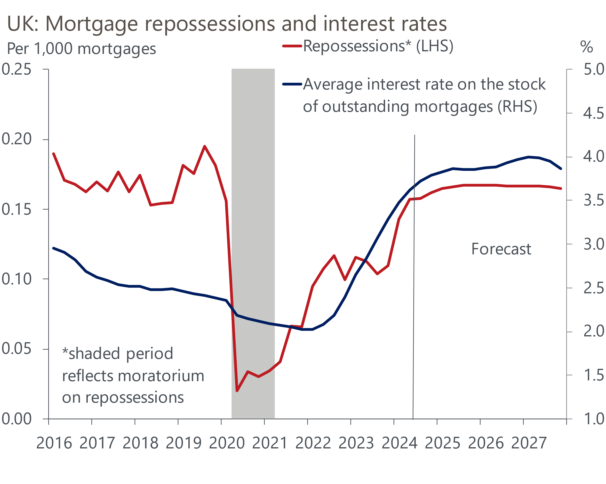
Source: Oxford Economics, Haver Analytics, UK Finance

Interest rates staying higher for longer is the key risk
We have utilised a series of scenarios featured in our Global Scenarios Service to see how our forecasts for mortgage arrears and repossessions would evolve under different assumptions.
We see a scenario in which interest rates are held higher for longer as the most damaging for the mortgage market. If underlying inflationary pressures were to prove stickier than we expect in our baseline forecast, this could result in Bank Rate being cut less quickly, higher gilt yields, and tighter credit conditions. Under these assumptions, we would expect a surge in household debt servicing costs and higher unemployment, causing the proportion of mortgages in arrears to rise again, reaching roughly 1ppt higher than the recent peak and remaining well above our baseline for the foreseeable future (Chart 5). Our estimates also suggest that the scale of the rise could be large enough to result in a noticeably higher repossession rate.
Chart 5: Higher-for-longer rates may result in a gradual but substantial and persistent increase in arrears
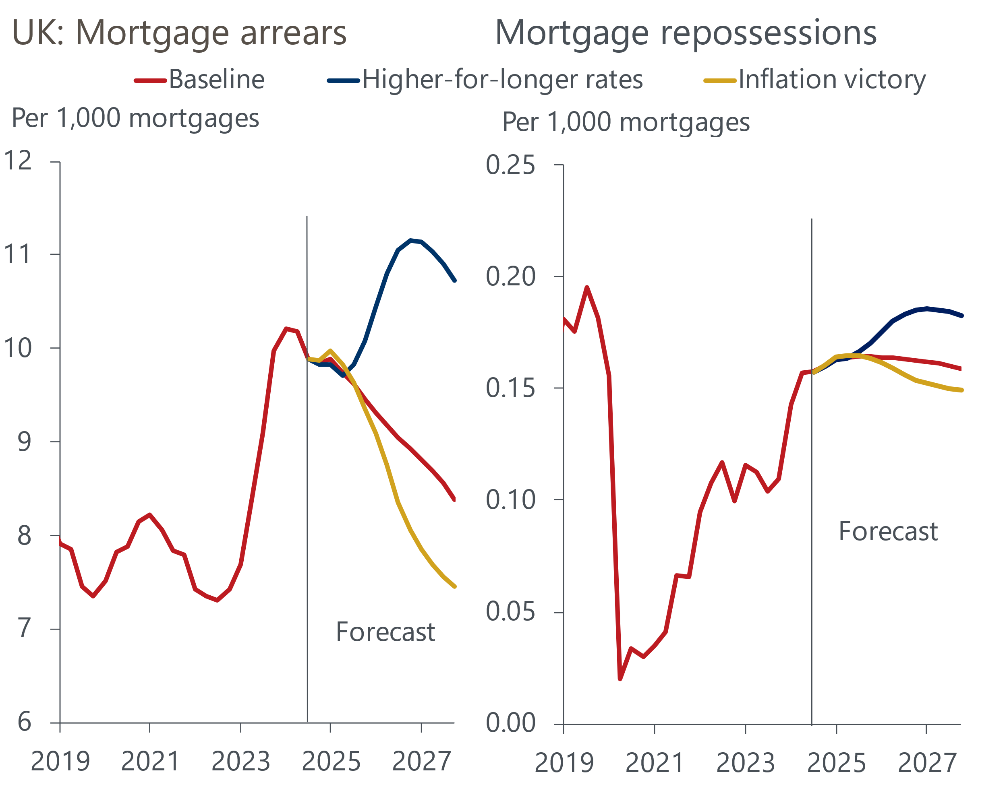
Source: Oxford Economics, Haver Analytics, UK Finance
In contrast, our inflation victory scenario finds more favourable outcomes for the UK mortgage market. In this scenario, near-term inflation prospects improve globally, resulting in lower inflation expectations and fading central bank caution over the pace of rate cuts. Our analysis suggests that arrears would fall at a slightly quicker pace than in our baseline projection. The outlook for repossessions under these scenario conditions also appears a touch more benign.

Appendix
We developed an empirical model to produce point forecasts for mortgage arrears that are conditional on our Global Economic Model (GEM) forecasts for the UK economy. To do this, we employed a linear regression model:
$${ARR}_{t}=C+ \sum_{i=0}^{1}{{β_{i}DSC}_{t-i}}++ \sum_{i=0}^{1}{{β_{i}UPILO}_{t-i}}+ \sum_{i=0}^{1}{{β_{i}RBM}_{t-i}}+ε_{t}$$
ARR is the logged proportion of the mortgage stock that is in arrears above 2.5% of the outstanding balance. DSC is the natural log of personal sector debt servicing costs (excluding FISIM) as a proportion of nominal household disposable income. UPILO is the unemployment rate. RBM is the average interest rate on the stock of outstanding mortgages. We find that all three of these factors have a positive relationship with mortgage arrears.
Our regression is run from Q1 1995 until Q4 2019. A dummy variable is used to account for regulatory changes introduced by the Bank of England's Financial Policy Committee in 2014, which introduced a stress testing mortgage interest rate for lenders and limited the proportion of mortgages with high loan-to-income ratios.
Given properties are foreclosed upon after a period of time in arrears, our forecast for repossessions simply uses repossessions in the previous period and past changes in our arrears projection.

